Supplementary Figure 1
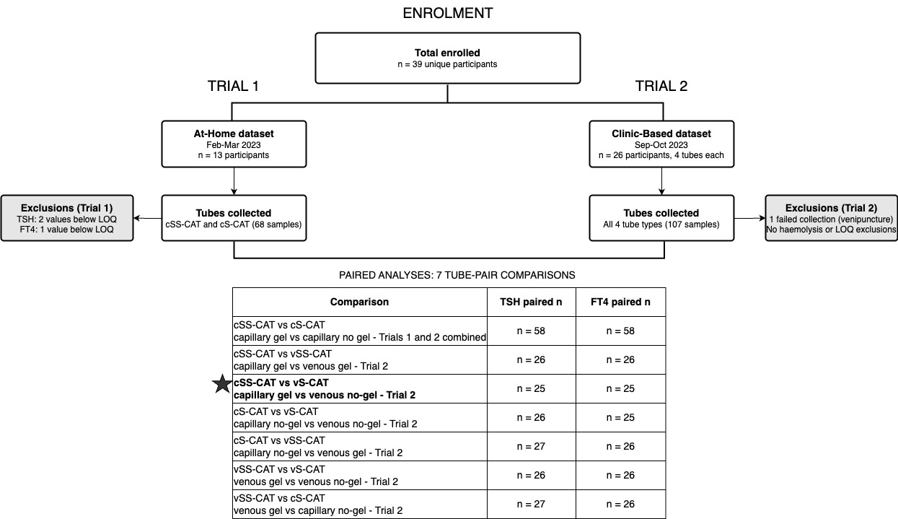
Supplementary Figure 1: Participant flow diagram. Trial 1 (At-Home dataset, February-March 2023) and Trial 2 (Clinic-Based dataset, September-October 2023) enrolled 13 and 26 participants respectively, with no overlap between trials (total n = 39). Exclusions per trial are shown with specific reasons. Paired n for each of the seven tube-pair comparisons reflects valid measurements after all exclusions.
cSS-CAT = capillary serum separator clot activator tube;
cS-CAT = capillary serum clot activator tube;
vS-CAT = venous serum clot activator tube;
vSS-CAT = venous serum separator clot activator tube;
LOQ = limit of quantification.

Supplementary Data 1: Specimen Collection Device Description and Specifications

1. Intended Purpose and Classification
The capillary blood samples analyzed in this study were collected using the Hertility Health Collection Kit (HER-KIT001). The device is a registered single-use, non-automated specimen collection and transport kit. It is classified as a Class A In Vitro Diagnostic Medical Device (IVD) under EU IVDR 2017/746 and registered as a General IVD under UK MDR 2002. The device serves solely as a specimen receptacle for sample collection and ambient transport to an accredited testing laboratory and performs no active analytical measurement.

2. Kit Components and Specifications
Each standardised user kit contains the following validated components:
- Micro-collection tube (1×): Capillary Serum Separator Clot Activator Tube (cSS-CAT, MiniCollect®, 0.8 mL) or Capillary Serum Clot Activator Tube (cS-CAT, MiniCollect®, 1.0 mL) featuring a silicon dioxide (SiO2) particle-based clot activator.
- Mechanical accessories: Disposable sterile lancets (5×), alcohol preparatory wipes (2×), cotton swabs (3×), and adhesive plasters (2×).
- Packaging and logistics: Detailed Instructions for Use (IFU), unique collection tube labels, laboratory return form, protective secondary plastic wallet containing absorbent material, and a prepaid return mail envelope.

3. Pre-Analytical Transport and Environmental Controls
- Logistics Compliance: Sample transport packaging strictly complies with UN3373 biological substance category B standards utilizing a robust three-layer system (primary tube receptacle, secondary protective plastic wallet with structural leak-proof absorbent material, and a rigid outer kit envelope)
- Temperature Tolerance: The device and its internal components are validated for storage and transit across a defined ambient temperature range of 5°C to 25°C.
- Stability Logistics: The partner laboratory enforces a maximum 7-day specimen acceptance timeframe from the point of collection, though all study samples arrived within a median transit duration of 13 hours.

